****What is HTML?****

* HTML stands for Hyper Text Markup Language.
* It is used for  building Web pages in HTML.
* It explains how a Web page is put together overall.
* There are many elements in HTML.
* HTML elements give browsers instructions on how to display content.

****Webpage****

* **A web page on the World Wide Web is a hypertext document.**
* **A web server sends web pages to the user, who then sees them on a web browser.**
* **Numerous web pages connected by a similar domain name make up a website.**

****HTML Elements****

* **A type of HTML document component, or HTML node, is known as an element.The HTML document is composed of a tree of simple HTML nodes, such as text nodes.**
* **They add formatting to several parts of the document where applied.**
* **Every element can have it’s own attributes(additional properties) :**

<Name of tag> some text, image etc.</Name of tag>

Examples of some HTML elements.

<p>Paragraph 1.</p>

<h3>Heading</h3>

****What are Tags?****

HTML tags are composed of three things: an opening tag, content, and an ending tag. Some tags are unclosed tags. An HTML document is viewed by a web browser from left to right and from top to bottom. In order to generate HTML documents and render their characteristics, HTML tags are used.. Each HTML tag has different properties.  
Syntax:  
<h1> content </h1>

**Tag names in HTML :**

* Tag names for HTML elements could also be written with any mix of lowercase and uppercase letters that are a case-insensitive match for the names of the elements in HTML; Tag names are case-insensitive.While it isn't a strict rule, writing HTML5 tags altogether lowercase is a widely used convention.

**HTML <sub> tag :**

* The HTML tag defines subscript text. Subscript text is displayed half a level below the normal line, and is usually displayed in a smaller font than normal.For example, within the chemical formula H2O, the amount 2 is rendered as subscript which has a smaller font and appears with a lowered baseline, by using the subsequent code :

*<body>*

*<p>Chemical formula of water is H<sub>2</sub>O.</p>*

*</body>*

****Meta tag :****

* The tag defines metadata about an HTML document. Metadata is data (information) about data.
* tags always go inside the element, and are generally used to specify character set, page description, keywords, author of the document, and viewport settings.
* Metadata won't be displayed on the page, but is machine parsable.Metadata is mostly used by browsers (how to display content or reload page), search engines (keywords), and other web services.
* Example :

Example code to define keywords for search engines:

*<meta name="keywords" content="keyword1, keyword2, keyword3">*

**HTML Comments:**

* HTML comments aren't displayed in the browser. Comments are often used to hide content.
* Comments also are great for debugging HTML, because you'll comment out HTML lines of code causing errors, which will make it easier to debug.
* Syntax :

*<!-- Write your comments here →>*

**HTML Attributes :**

* An HTML attribute is a markup element that is used to modify how an HTML element behaves or appears. For instance, attributes can be used to alter an HTML element's colour, size, or functionality.

Attributes are used by including them in an opening [HTML tag](https://www.digitalocean.com/community/tutorials/what-is-an-html-tag):

<tag_name attribute_name="value">Content</tag_name>

## **Unordered HTML List :**

* HTML Unordered List(Bulleted List) displays text in bulleted format . We can use an unordered list wherever we don't have to show things in any specific order.
* The ul tag is used for creating an unordered list.
* There are often four styles of bulleted list:
* **Disc**
* Code to apply the disc shaped bulleted list :

*<ul style="list-style-type:disc;">*

*<li>HTML</li>*

*<li>CSS</li>*

*<li>Javascript</li>*

*</ul>*

* **Circle**
* Code to apply the circle shaped bulleted list :

*<ul style="list-style-type:circle;">*

*<li>HTML</li>*

*<li>CSS</li>*

*<li>Javascript</li>*

*</ul>*

* **Square**
* Code to apply the square shaped bulleted list :

*<ul style="list-style-type:square;">*

*<li>HTML</li>*

*<li>CSS</li>*

*<li>Javascript</li>*

*</ul>*

* **None**
* Code to remove shapes :

*<ul style="list-style-type:none;">*

*<li>HTML</li>*

*<li>CSS</li>*

*<li>Javascript</li>*

*</ul>*

* When a list is created inside another list, it is called Nested list/sublist.
* In nested lists, the sublist is written as a child of list item.

**HTML <a> target Attribute :**

* To specify the location of a document to be opened when a link is clicked, target attribute is used.
* Example : In order to open a linked document in a new tab or window, the below given code can be used :
* *<a href="abc.com" target="_blank"> abc.com website will be opened into a new tab</a>*

****Using Img tag as an HTML link****

* In order to use an image as a link in HTML, the <img> tag which is used for displaying images, is written inside <a> anchor tag, and the url of the website to open is specified in the href attribute of the anchor tag. Width and height attributes can also be given to the <img> tag to define width and height of the image to be displayed.

*<!DOCTYPE html>*

*<html>*

*<head>*

*<title>Adding images as links in HTML</title>*

*</head>*

*<body>*

*The below given image will act as a link :<br>*

*<a href="https://google.com">*

*width=”150" height="70">*

*</a>*

*</body>*

*</html>*

**HTML Self Closing Tag :**

* Self closing tags do not need to be closed manually, they do not have a separate closing tag to close these tags.
* <img/>, <input/>, <br/>,<hr/> etc are examples of self closing tags.
* In HTML 5, we no do not need to include the slash character to denote a closing tag, because it is understood automatically that empty elements do not require any closing tag, hence <br/> can also be written as just <br> (Without the slash)
* Empty tags, singleton tags, void tags are alternate names for self closing tags.

**Ids and classes :**

* ids and classes cannot have spaces i.e. "firsttable" is a valid id and class, but "first table" is not a valid id or class.

****<div> tag :****

* + - **<div> tag is used to create a division/section in an HTML document.**
    - It is used as a container for various HTML elements, which can be used to style that section with CSS or can be used to apply javascript to that particular div.
    - It can be styled with the help of class or id attribute.
    - It supports all types of content.
    - It is a block-level element, hence it always starts from a new line.
    - It  takes up the entire width that is available.

**<span> tag :**

* It is an inline container which can be used to mark a particular part of text or even a document.
* As it is an inline element, it does not begin on a new line (unlike the block element)
* Inline elements will only take up the width that is necessary and not the entire width available.

****Example demonstrating difference between <div> (Block element) and <span> inline element :****

****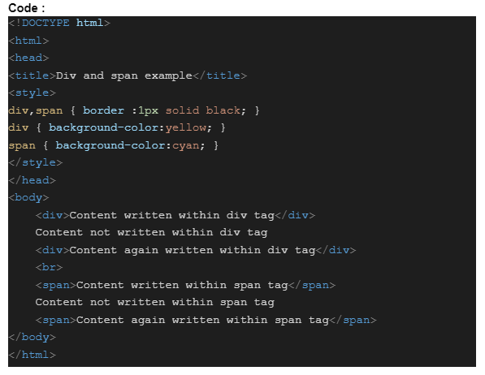****

****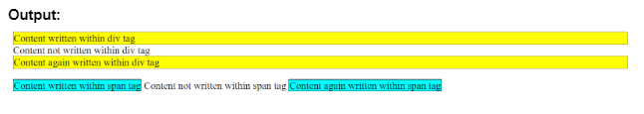****

HTML Forms :

An HTML form is used to gather input from the user.

<form> tag is used for creating an HTML form which can allow users to input data. <form> tag can contain different types of different elements, like text fields, radio buttons, checkboxes, submit buttons, etc.

Type attribute of <input> defines the various ways in which <input> elements can be shown.

Various attribute values for the “Type” attribute are mentioned below :

1. <input type="text">

It creates an input field supporting single-line text.

2. <input type="radio">

Creates a radio button (can select only one choice with radio button)

3. <input type="checkbox">

Creates a checkbox (can select zero or multiple choices)

4. <input type="submit">

Creates a submit button (for submitting data in form)

5. <input type="button">

Creates a button

Name attribute :

Name of an HTML element is defined by the name attribute.

Placeholder attribute :

This attribute gives a hint to the user, stating the value to be expected from the user for an input field. (expected input format).

Hint is shown in the input field before value is entered by the user.

Example:

Code:

<form>

<input type="text" placeholder="First Name"

<br>

<input type="text" placeholder="Last Name">

</form>

The <textarea> Element :

It is used to create a field which can contain multiple lines.

Example:

<textarea name="anyName">

Creates a textarea with 30 rows and 20 columns

</textarea>

Difference between input type=”text” and textarea :

Textarea can contain multiple lines in it, whereas input type=”text” is used to contain only one single line.

The method Attribute

It describes how to send data through form.

Data collected through form can be sent using GET or POST method.

GET method :

After a form is submitted using the GET method, its values are visible in the address bar of the new tab of the browser.

It should be used for sending data which is not secured, and not for information that is sensitive.

Syntax :

<form method=”GET”>

POST method :

After a form is submitted using the POST method, its values are not visible in the address bar of the new tab of the browser.

Syntax :

<form method=”POST”>

Interview Questions

****1.** What is HTML?**

* HTML stands for Hyper Text Markup Language.
* It is a language of the World Wide Web.
* It is a standard text formatting language that can be used to create and show pages on the web.
* It can be used to make written text more interactive, and can also turn text into images, tables, etc.

****2. What are Elements?****

* They are composed of 3 main things : A starting tag, its content and an ending tag.
* Some elements are unclosed elements.
* HTML tags are some text that are used to create elements.
* Every HTML element has various properties.
* Syntax  
  <h1> content </h1> In the above given example, h1 is the element, whereas <h1> and </h1> tags are used to create the h1 element.

**3. How do attributes work? What are they used for?**

* Every tag can have additional attributes that alter how a tag acts or is shown.
* For instance, an <img> tag has src attribute, which is used to provide the path of source of the image to be added.
* A tag's type attribute allows you to indicate whether a field is a text field, checkbox, radio button etc.
* They are written after the tag's name, and are written inside the two angular brackets.
* Always use opening tags or self-closing tags when applying attributes.
* Attribute names and it’s values are case sensitive, but it is recommended that they should be written exclusively in lowercase because they are case-sensitive.
* Syntax  
  *<elementName attributeName="attributevalue">content inside the element</elementName>*

**4) In HTML, how do you divide a group of texts?**

Below given tags can be used to divide a group of texts in HTML :

* <p> tag : This tag is used to divide text into different paragraphs.
* <br> tag : This tag creates a new line in an HTML document, and transfers flow of content into a new line.

****5)**How should list components be aligned in an HTML document?**

* Using indents, we may align the list components in an HTML file.You can readily align and identify the multiple lists and the components they contain if you indent each nested list outwardly more than the parent list.
* **Example code for creating nested lists in HTML :**

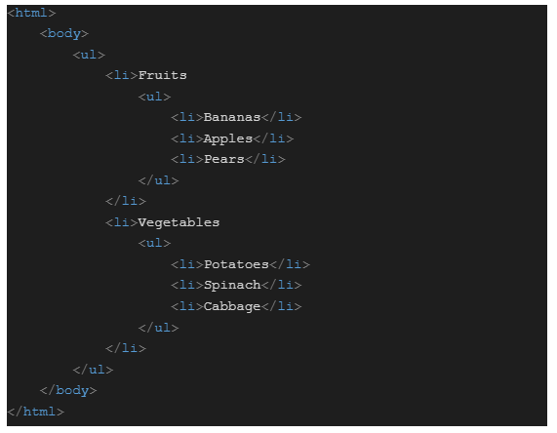

****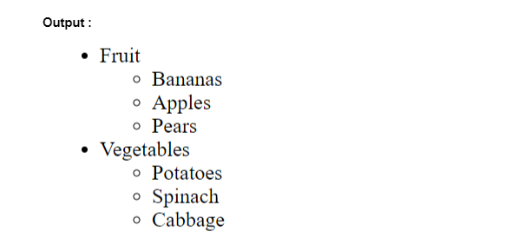****

**6) When are HTML comments used?**

* You can add code comments to your HTML documents to make the code easier to read. These do not appear in the browser but assist you in leaving notes for yourself and other developers regarding the purpose of a certain HTML section.
* Any text in the midst of the comment, even if it contains proper HTML, will be completely ignored.
* Syntax for HTML comment :

<!-- HTML Comment is written here --

**7) Identify a few typical lists that are used in page design.**

* To construct a page, many common lists are used. Any of the following list kinds, alone or in combination, may be chosen:
* A numbered format is used to present elements in an ordered list, whereas an unordered list does not follow a numbered form hence it is known as an unordered list.
* Ordered list : Denoted by <ol> tag, they display elements in numbered format.
* Unordered list : Denoted by <ul> tag, they display elements using bullet format.

**8) How do you make an HTML hyperlink?**

* In HTML, a hyperlink connecting one page to another is made using the anchor tag. Images can also have the links added to them.

**9) What does HTML formatting mean?**

* The method of converting text into HTML results in a more appealing appearance and feel. It utilizes several tags to make text bold, add emphasis, and underline text.

**10) Is a hyperlink restricted to text only?**

* No, hyperlinks can be used on both text as well as images. A hyperlink that connects one page to another is defined by the HTML anchor tag. The HTML anchor tag's "href" element is its most crucial component.

**11) Is <!DOCTYPE html> an HTML tag?**

* No, the <!DOCTYPE html> declaration isn’t an HTML tag.    The first line of any HTML document must be a declaration.
* There is no HTML tag in the declaration. The browser receives "information" from this declaration about the document type to expect.
* It tells the browser to run in "Standard mode" and avoids behaviour of old browsers.
* The <!DOCTYPE> declaration is case insensitive.

**12) What would happen if the HTML tags were not separated by any text?**

* If there was no text in between the tags, there would be nothing to format. Nothing will therefore show up on the screen.
* Some tags, such as those that don't have a closing tag, like the <img> , <br> tags, don't need any text in between them.

**13) In HTML, how do you make nested web pages?**

* Nested web pages are essentially web pages within web pages. The built-in iframe tag in HTML can be used to construct nested web pages. An inline frame is defined by the HTML <iframe> tag.
* ****For example:**** The code below will generate an iframe with the specified width and height and show the Wikipedia page (whose URL is added in the value of src attribute)

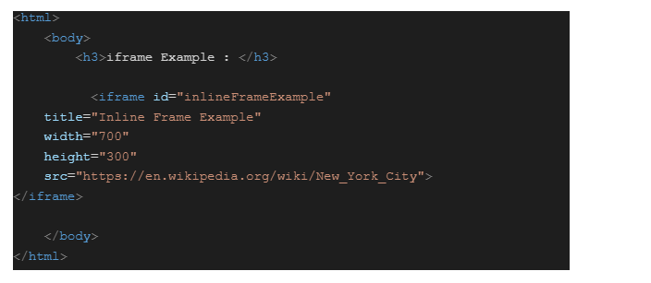

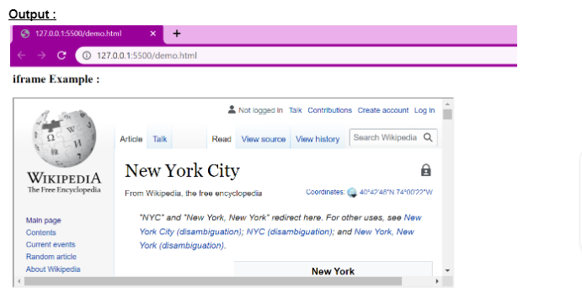

**14) How can buttons be added to HTML?**

* To add buttons to an HTML web page, we can utilise the built-in Button tag.
* For Example:  
  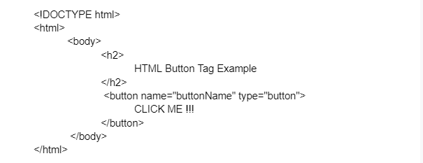

**15) What does HTML's alt property mean?**

* When an image cannot be loaded due to a technical issue, the alt attribute is used to show text in its place.
* For Example:  
  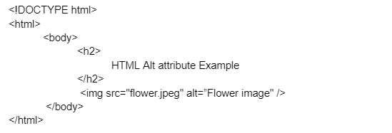
* For people who are blind or visually challenged, screen readers can read out the text in place of the image. As a result, it is a crucial characteristic for accessibility.

**16) Explain meta tag**

* A HTML document's metadata is defined via the <meta> tag. Information related to data is referred to as metadata.
* The character set, page description, keywords, author of the document, and viewport settings are among the common information that is included in <meta> tags, which are always contained inside the "head" element.
* The page will not display any metadata.